PARISH NEWS
The Deverills & Crockerton

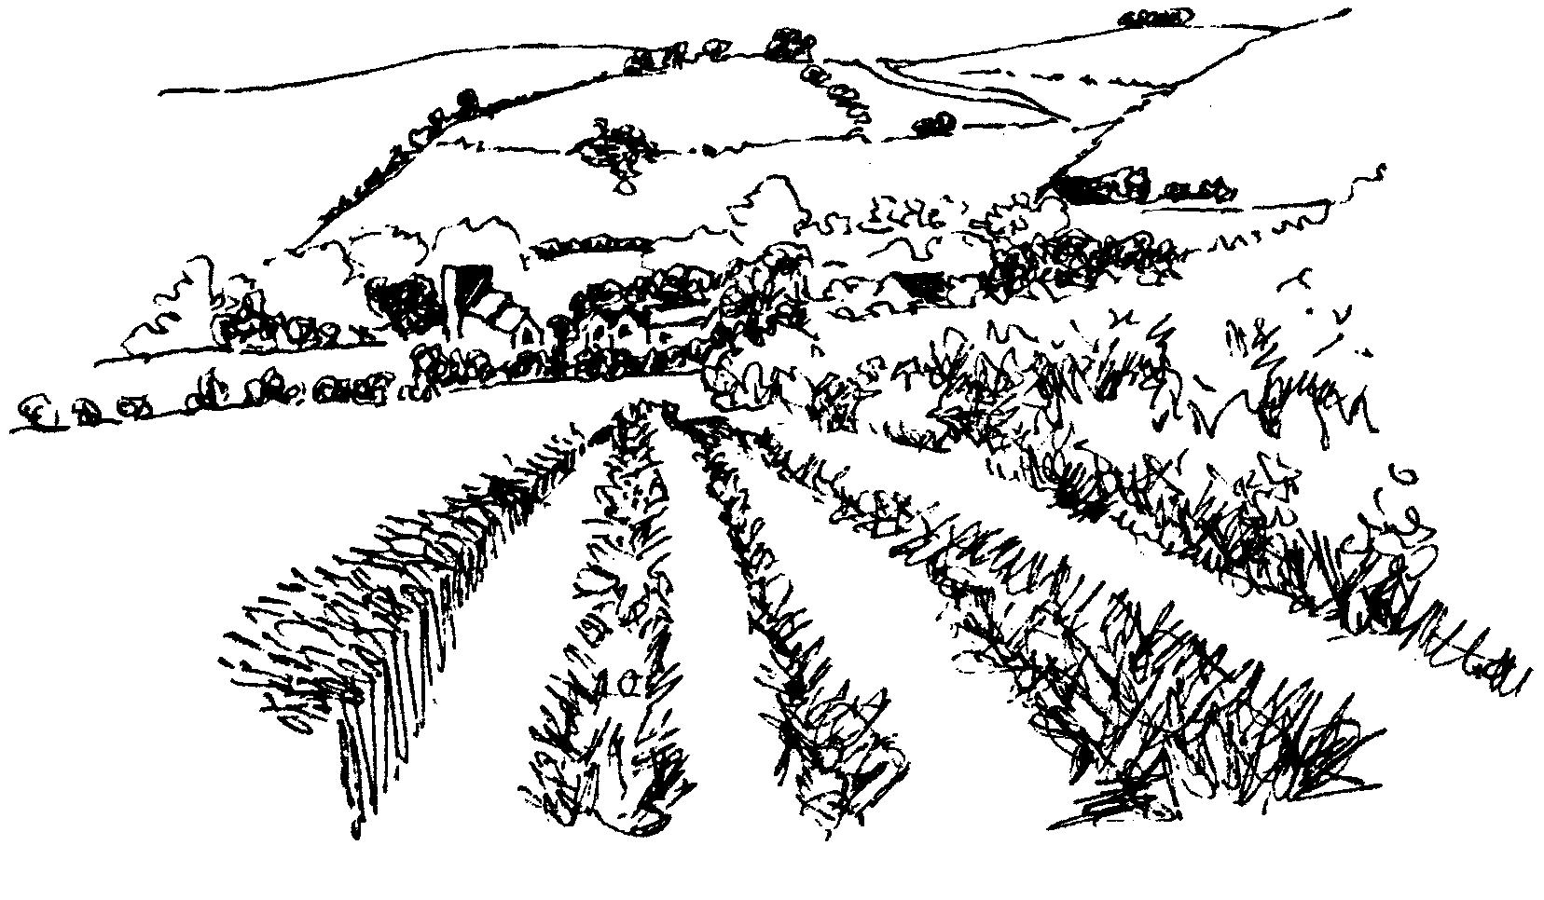

October 2009

Look inside for local information

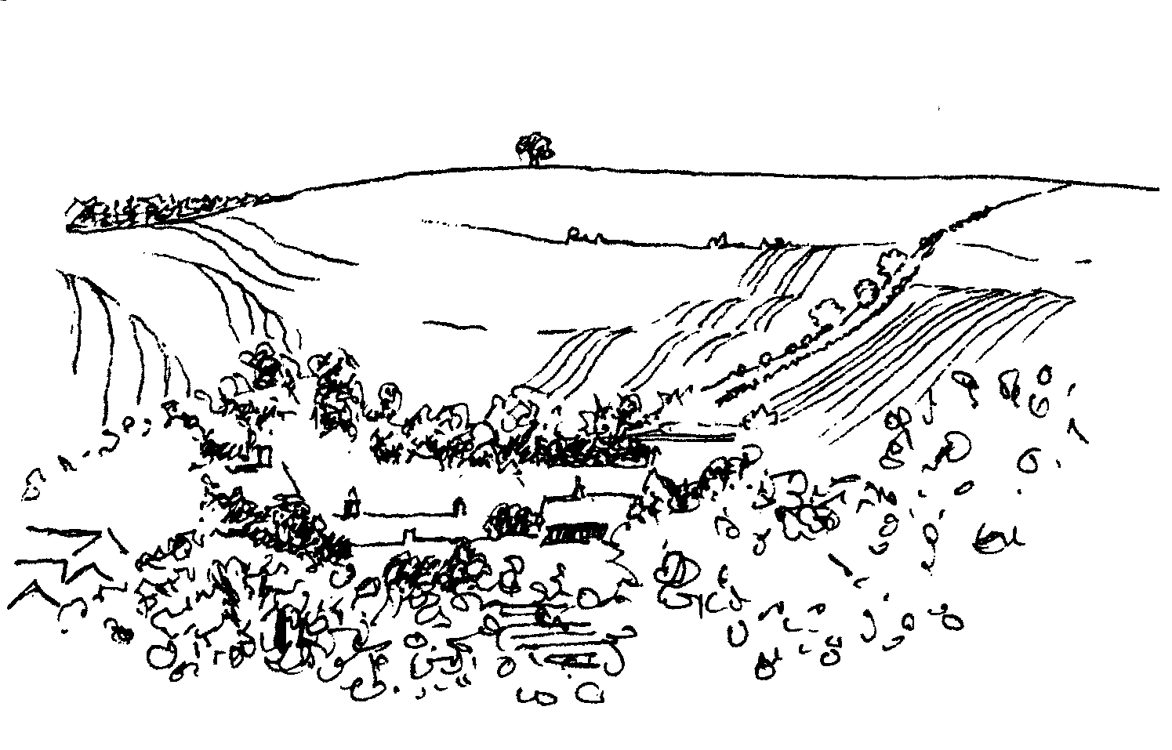
-2-

Deverills Chamber Choir
Invites you to an informal concert
Friday 20th November at 7.30 pm
At Longbridge Deverill Church
Light refreshments - small donation appreciated
Come & listen to a variety of songs - you may be inspired to join us!
For more information please contact Claire Johnson 840787

Longbridge Deverill Village Hall
HARVEST SUPPER
Saturday 10th October 7.00 pm for 7.30 pm
All are welcome to this popular annual event
Bring your own drinks
Tickets £10 from Sylvia Titt (214825)
Upper Deverills Village Hall
Halloween Harvest Supper
Saturday 31st October
7.00 pm for 7:30 pm
Book early for this popular event
Tickets £10 from Richard Cousens (844970)

Coffee, Cards and Chat
Come and enjoy looking at the new range of cards,
ribbons, wrapping paper, and other exciting items
displayed by John and Maddie Goodden
in the Upper Deverills Village Hall on Thursday 19th February
between 10.30 and 12.00 noon - everyone is welcome
Donations will be made to the hall and the church



Deverill Valley Clarinet Quintet Concert
Saturday 17th October 8.00 pm Longbridge Church
Tickets £10.00 phone Julian Wiltshire 844152
Claire Johnson (clarinet), Magnus Johnston (violin), Sarah Bayley (violin),
Polly Wiltshire (viola) and Harriet Wiltshire (cello)
We will celebrate the most exquisite music written for clarinet,
beautiful Quintets by Mozart and Brahms and Eilean Shona by Holbrooke
Pre - concert supper 6.30 pm at Longbridge Village Hall
Tickets £10.00 (with glass of wine) phone Janet Budgen 218203
Cheques: PCC Deverills & Horningsham - profit Deverill Churches Fabric Fund Come and enjoy a delicious meal and the sound of golden warmth and
mellowness at this Autumn concert.

-3-
The Rector reflects:
I listened, watched and read, with some incredulity, reports that adults who regularly transport groups of children to events will have to be vetted by the ISA (Independent Safeguarding Authority). Immediately I wondered whether a further layer of bureaucracy would put volunteers off altogether. While it is necessary to ensure that children are protected, it seems to me that over-regulation may remove the good will on which many children’s groups depend.
I remember some time ago standing in a local shop, and being greeted by the wonderful smile of a very small child who was with her mother ahead of me in the queue. I smiled in response and said ‘Hello!’ I was rather taken aback when the little girl’s mother, ignoring me entirely, told the child quite forcibly how dangerous it was to speak to strangers! The child was entirely safe with her mother. I was simply being friendly, honouring the child herself. Seeing the adults in conversation might have been a useful lesson about how to begin a conversation with someone you do not know. Where are children to learn helpful strategies about how to relate to others if not with their parents and other trusted adults? This is increasingly important for children who spend long hours in front of computer screens – don’t start me on that!
I think children today have too few champions. Organisations like The Children’s Society, Childline, Barnardo’s etc are right to speak up in favour of greater protection. We must also acknowledge that sadly there are people who are determined to prey on vulnerable youngsters. But as a percentage of society, their numbers are few and I wonder if the fear we risk instilling in our children is disproportionate.
The new vetting proposals seem to suggest that everyone is guilty unless they have a certificate to say otherwise. Suspicion breeds suspicion and society wonders about the motives of those who choose to work with the young, especially men. However, some procedures are necessary. Yet at the same time, we lament the lack of positive role models for many children today. In addition, to make things more complicated, we are still likely to find ourselves trapped by gender expectations.
I hope that common sense and a careful overview will govern the promised review of current proposals. Assessing matters in the short term without looking to longer-term changes in society could be something that, in the end, society regrets.
Norma Payne
Ride and Stride
Congratulations to Richard Munro who represented the parish and cycled 70 miles to over 30 churches raising more than £500 for the Wiltshire Historic Churches Trust. Thank you to all who generously sponsored him supporting this charity which provides grants for the upkeep of our county’s beautiful churches.
Christmas cards for Sudan
These beautiful cards, handmade by Jane Yates, will be on sale in our churches from Mary Royall and at the Thursday Group from Barbara Beilby. The proceeds help to support the work of the church in Sudan.

-4-
Longbridge Deverill and Crockerton Parish Council
Following an incident concerning a horse and a lorry in Clay Street in Crockerton during September, residents attended the September Parish Council meeting in force to see if anything could be done to alleviate the speeding problems. P.C. Vicky Pegrum also attended along with the P.C. from Mere, who has had similar problems, and a Traffic Management Officer from Devizes. Various ideas were discussed, including Community Speed Cameras, Speed Indication Devices and wheelie bin stickers. However, nothing can be done until evidence is collated to prove the seriousness of the problem. Wiltshire Council have agreed to put the black rubber lines on the road in approximately 6-8 weeks time to monitor the traffic, but until then, the only way to gather information is for as many residents as possible to advise Wiltshire Police if they see any speeding vehicles. Registration numbers would be a great help, but a good description of the vehicle is also helpful. PC Pegrum could then collate the calls and random speed checks and a police presence in the village could be targeted at the optimum times. So please call 0845 408 7000. If the same car is reported time after time the Police can send a warning letter and you may save a life.
At the same meeting Councillors reported that they had again had complaints regarding dog fouling, especially in Clay Street, Crockerton and Sand Hill Lane, Longbridge Deverill. Dog walkers are reminded that it is an offence not to clear up after your dogs and you could receive a fine. The Parish Clerk has a small supply of sticky notices reminding owners of their obligations from the Dog Warden at Wilshire Council, but please be aware that these can only be placed on your own property and not on telegraph poles etc. The wardens will also follow up reports from the public if an address for the dog (and its owner!) is known.
With November approaching, please could anyone considering holding a firework party remember to warn horse and pet owners and livestock farms locally. A recent party in Crockerton caused great distress.
Please note that the Parish Council is not only here for complaints! We are always pleased to see anyone at our meetings and the next one is at Longbridge Deverill Hall on Monday 2nd November at 7.30 pm.
Helen Few – Parish Clerk
Wylye Tennis
The 'Chippenham & District Tennis League' match season is complete. This is sad as we have had a great time, playing, competing, travelling to other clubs and after match visits to our hosts’ pubs for supper. The Mixed ‘A’ team at one time were second in Division 2 and in a promotion position. But a few matches lost toward the seasons’ end left them out of the top two yet secure in mid table, so they will in remain in Div. 2 for 2010. Our Mixed ‘B’ players put together some good results toward the season end finishing off the bottom place! The ‘Ladies’ team - competing for the first time in the league - also gained good winning results, later on finishing a commendable third, an excellent first year result. Until the 2010 league season starts in April we will be playing social tennis, anyone who would like to play please to contact me, Colin Singer on 213696. PS Tennis balls at £2.00 per can of 4.

-5-
Broadband Action Group
A full report of our findings will be in the November Parish News.
Deverills Cricket Club AGM
Monday 19th October 7.30 pm in The George, Longbridge Deverill.
Longbridge Deverill Village Hall
Thank you to Willem Noorlander who kindly donated £589 received from Hill’s waste for the recycling at Longbridge Garage. This will go towards the cost of renovating the stone buttresses at the hall which are being worked on at present by Ashley Baxter, a local stonemason. The committee thank Willem and the villagers who by recycling at the garage have made this donation possible. Please keep recycling! Future events: Saturday 10th October - Harvest Supper, Saturday 12th December - Community Carols.
Exhibition & Talk on Elephant Conservation Network Thailand
The whole event went far better than we could have imagined, it was a marvellous turnout, around 80 people came to my talk and exhibition preview. I sold 15 pictures that night, and the same over the next few days. In all I have been able to bank £2,500 for our work with wild elephants in Thailand - although as those who heard my talk will know, much of our work is with villagers - helping them develop occupations not dependant on the forest and so not competing with elephants. Thank you to everyone who supported this effort, especially my mother and those she dragooned into helping out with food, the evening would not have been as good without that sustenance.
Many people may be amused to read this excerpt from my uncle Humphrey Lyttelton’s book ‘It Just Occurred To Me’: “I should mention another artist whose work hangs in my house. Luuk Add is a painter in Thailand specialising in abstract work. The picture I have is of an imaginative structure of tangled lines and shapes which, since some of the strokes are made with a dry brush and are therefore indistinct, has a three-dimensional appearance, as of twisted metal wire into which one could put one’s hand. The fact that I am describing it in this way indicates that it does what an abstract should do, that is, to stimulate the mind of the viewer. It is one of my favourite acquisitions, which I have hung in my hallway where it provides, if nothing else, a talking point, since Luuk Add was three years old when he painted it, and is an elephant. I draw your attention to a worthy cause, that of elephant conservation. Luuk Add, an orphan, was rescued from the streets of Bangkok, where he survived by begging for bananas outside restaurants and night clubs (it sounds more and more Toulouse Lautrec as we go on!). His artistic talent was discovered in the Elephant Conservation Centre in Lampang. The picture is indeed delightful, and I acquired it from my niece, Belinda Stewart-Cox, a distinguished worker for animal conservation in the field, mainly in Thailand. The discoveries that have been made about the ability of some, not all, elephants to paint consistent, intelligent and highly individual pictures are, if you look into them, rather spooky. You’ll find yourself spooling back through your memory to recall if you have ever said anything derogatory about an elephant in its hearing. They have memories like …. well, an elephant.”
Belinda Stewart-Cox


-6-

Deverill Valley Creations
invite you to a coffee morning in aid of
Breakthrough Breast Cancer and Cancer Research
Thursday 8th October 10.30 – 12.30 at 92 Monkton Deverill
Stalls to include: Cakes, Gifts, Raffle, Deverill Valley Creations,
Phoenix cards, Pampered Chef, Partylite Candles
All Donations most welcome
More information: Judith 845255 or Ann 216007
Salisbury Theatre Club Trips
Monday 19th October
After Miss Julie by Patrick Marber
Monday 16th November
Arsenic & Old Lace by Joseph Kesselring
The cost is £17.00: theatre seat £12.00 and coach trip £5.00
Booking and payment in advance to Mary Stewart Cox Tel 840877
Longmead, Brixton Deverill, Warminster BA12 7EJ
Coach leaves Kingston Church 6.10 pm collects through the Deverills
Performances begin at 7.30 pm

Coffee Morning
In aid of Kampala Music School
Tuesday 13th October 10.30 am - 12.30 pm
At Frog Lane Farmhouse, 84 Sand Street
Ugandan hand made bead necklaces, earrings and bracelets, batik and banana leaf cards, bookmarks, Christmas cards
Tea, coffee and homemade cakes
Claire Johnson 840787


Fight for Sight Charity Fair
Thursday 1st October 10.00 am - 3.30 pm
Rye Hill Barn, Longbridge Deverill, BA12 7DE (Maiden Bradley road)
Entrance £3 - Lots of lovely stalls, gifts for all the family
Bring friends, enjoy coffee & delicious snacks by Sandy Parrish
All profits go to research into debilitating eye diseases
Further information at www.fightforsight.org.uk

-7-
Deverill Valley & Crockerton Women's Institute
Our evening meeting on Monday 12th October features Ann Orr asking ‘Are you legally prepared?’ This will inform us about wills, and many other legal areas. Anyone for Scrabble? All levels of expertise or beginners are welcome on (usually) the fourth Monday evening at Longbridge village hall. We play for fun and award small prizes for highest, lowest and midway scores. We would also like to hear of Mah Jong players, some of us are learning the British rules and need practice! For more details about these and other WI events call 212415 or 840209.
The Cast on Club
Thank you to those who attended the September meetings which were very successful. Meetings this month will be on Thursdays 8th and 22nd October at 10.30 am at Judy Munro’s house, Whitepits Lodge, Kingston Deverill. Everyone is welcome whether you have knitting skills or not, help will be at hand! The pattern is simple. If you have any double knitting yarn and a pair of 3mm knitting needles, please bring them along. We look forward to seeing you. If you have any queries or need directions call Judy Munro 844385.
Gardeners Question Time Evening
This event on Monday 19th October will be hosted by Soroptimist International of Bath at Prior Park Garden Centre in Bath, to raise money for Dorothy House Hospice. The evening programme will be: 6.00 to 7.00 pm the garden centre open for shopping (20% of sales go to the charity); 7.00 to 7.30 pm ‘Nibbles and Wine’; 7.30 to 8.30 pm Gardeners Question Time; then the raffle will be drawn and there will be a chance for last minute shopping. The evening will be informative but light hearted, so please come and join us. Tickets cost £6, including refreshments, and are available from Gill Hurd 840023.

CARDS FOR GOOD CAUSES
Christmas cards for over 35 charities with more than 250 designs
Christmas wrapping paper, Advent calendars, stocking fillers etc.
The Ginger Piggery at Boyton
Wednesday 28th – Saturday 31st October 10.00 am - 4.00 pm
Do come and bring your friends
Clippers & Windjammers
Great days of square rigged sailing ships in stories and pictures
Saturday 21st November in Codford Village Hall
Doors open 6.45 pm for a glass of wine,
Performance at 7.15 pm followed by supper
Information & Tickets £15 from Jane 840258 or Annie 840184
In aid of Hope & Homes for children and
Friends of Heytesbury, Knook & Tytherington Churches
-8-

SERVICES PARISH OF DEVERILLS & HORNINGSHAM
Sunday Trinity 17
4th October Kingston 8.00 am Holy Communion 1662
Longbridge 10.30 am Morning Worship
Horningsham 5.30 pm Harvest Festival* & Auction
Sunday Trinity 18
11th October Kingston 10.30 am Harvest* & Holy Communion
Horningsham 11.15 am Holy Communion
Sunday Trinity 19
18th October Longbridge 8.00 am Holy Communion 1662
Brixton 10.30 am Holy Communion
Sunday** Last after Trinity
25th October Longbridge 10.30 am Holy Communion
Horningsham 11.15 am Morning Prayer
Brixton 6.00 pm Evening Prayer
Sunday All Saints
1st November Brixton 8.00 am Holy Communion 1662
Longbridge 10.30 am Morning Worship
Horningsham 4.00 pm (tbc) All Souls

**British Summer Time ends - clocks go back 1 hour

Tuesday, Wednesday, Thursday, Friday Longbridge 8.30 am Prayers
Wednesday Longbridge 10.15 am Holy Communion
*Harvest Festival collections
It would be greatly appreciated if offerings of dry goods such as flour, sugar, rice, pasta, etc. and tinned items could be brought to the Festivals. These will then be distributed to local Food Banks which aid individuals and families suffering hardship.
Parish Prayer Group meeting - Deverills and Horningsham
Tuesday 6th October from 7.00 pm to 8.00 pm at Mary Royall’s house, Sandhill Lodge, Longbridge, to pray for our communities.
Pew for sale from Longbridge church
If you are interested in buying this pew please contact Elisabeth Atkinson on 212129.

The Deverills & Horningsham Register
Death announced of
Charles Booth Jones on Wednesday 16th September
Funeral at the Minster
David Holmes on Wednesday 23rd September
Baptism at Longbridge
Emily Priest on Sunday 27th September

-9-
SERVICES PARISH OF CORSLEY & CHAPMANSLADE
Church Cleaners for October
Kingston - Mrs Stratton & Mrs Mounde
Brixton - Mrs Armstrong & Mrs Burridge
Longbridge - Monday 5th October 9.30 - 10.30 am - all helpers please
Church Flower Arrangers for October
Kingston Brixton Longbridge
4th Oct Mrs Noonan Mrs Mcdonald Mrs Steptoe
11th Oct Mrs Munro Mrs Lawson Mrs Atkinson
18th Oct Mrs Munro Mrs Lawson Mrs Atkinson
25th Oct Mrs Gatt Mrs Greenwood Mrs Honley

Contact the Clergy
Please contact Norma Payne (841321) or Di Britten (01373 832515) if anyone is housebound and would like communion or a visit at home;
or if someone is ill and needs our prayers; or to discuss any church matter.
Office administrator phone 210149 or email: office@cleyhill-team.org.uk

Ivy House St Denys Retreat Centre
A place for rest, refreshment and renewal
Wednesday 7th October - Quiet Day
Led by Sister Theresa CSD
To book and for more information please phone 214824
Sunday Trinity 17
4th October Corsley 9.00 am Harvest & Holy Communion*
Sunday Trinity 18
11th October Chapmanslade 9.00 am Holy Communion
Temple 11.00 am Morning Prayer
Sunday Trinity 19
18th October Chapmanslade 9.00 am Holy Communion
Corsley 6.00 pm Prayer & Praise
Sunday Last after Trinity
25th October Temple 9.00 am Holy Communion 1662
Corsley 10.30 am Parish Service
Sunday All Saints
1st November Corsley 9.00 am Holy Communion
Parish Prayer Group meeting - Corsley and Chapmanslade
Sunday 18th October 6.00 pm in St. Margaret's, Corsley, after Prayer and Praise.

-10-
MERE LITERARY FESTIVAL
MONDAY 12th: The Voyage of the Beagle. Darwin’s extraordinary adventure aboard Fitzroy’s famous ship. An illustrated talk by James Taylor about the voyage that led to Darwin’s radical theories and publication of On the Origin of Species.
Grove Buildings 7.30 pm *£6 in advance £7otd
TUESDAY 13th: So What About Adam & Eve, then? A discussion on relevance of Biblical creation stories to modern society & science. Lecture Hall 2.30 pm Free
Women in History with Clare Mulley, Adrian Tinniswood and Kate Williams Three noted biographers discuss famous and less well known women of history and the subjects of their recent books. Grove Buildings 7.30 pm*£6 in advance £7otd
WEDNESDAY 14th: The Druid View of the World. Penny Billington, author and druid, talks on the druid view of our world. Grove Buildings 2.30pm*£3
Film Night Wiltshire Moviola ‘The Young Victoria’. Lecture Hall 7.30 pm*£5
THURSDAY 15th: Creation in an Afternoon. Poems & readings inspired by aspects of creativity from nature to nurture, gardening to painting, cooking to writing, crafts and skills. Come and listen, bring a favourite piece to read or be read.
Lecture Hall 2.30 pm Free
Live Theatre - Chester House Productions present ‘Florence’ a full length play on the life of Florence Nightingale. Lecture Hall 7.30 pm *£5 in adv. £6otd
FRIDAY 16th: Writing Workshop. A workshop with emphasis on writing for young people led by Sue Ashby Numbers Limited. To book contact organizer.
Grove Buildings 2.15 – 5.00 pm £12
Poetry in the Grove. Showcase readings of poems short-listed in this year’s open competition, prizes awarded by audience vote. Come and choose your favourite. Featuring a talk by the Brimstone Press. Grove Buildings 7.30 pm Free Admission
SATURDAY 17th: Coffee & Talk with Local Authors. Hear how authors from Mere and district made it into print. Grove Buildings 10.15 am retiring donations
Children’s Event. John Rowe children’s author, illustrator. Library 2.00 pm *Free
Encore! Mere Drama Society: two Woolstore Festival prize-winning One Act Plays
Lecture Hall 2.30p.m. Retiring Donations
Louis de Bernières and Ilone Antonius-Jones in concert ‘The Antonius Players’. A unique blend of music, poetry and amusement. United Reformed Church 7.30 pm *£8 in advance/£10 otd
SUNDAY 18th: Award Ceremony. Adjudications with Louis de Bernières, Sue Ashby, Mary White. Lecture Hall 3.00 pm. Book stalls 2.30 pm. Free admission
*Tickets from Mere Information Centre 01747 861211 or from the Festival Organiser 01747 860475, Postal Booking Forms on www. merelitfest.co.uk
The Quiz Sheet, Guided Mere History Trail, Book Stalls, all profits made are in aid of the Mere & District Linkscheme - Reg. Charity No: 1062328
Mere & District Link Scheme is here to help you if, for whatever reason, you are unable to get to the doctor, chemist, hospital, dentist, even shops or hairdresser. All we ask in return is a donation which you put in a sealed envelope. Last year we made just over 1,000 journeys, of which nearly 400 were to Salisbury District Hospital at Odstock. If you need our help just phone 01747 860096.

-11-
Recipes of the Month
Apple Chutney from Dianna Stevens
5 lbs peeled and chopped apples 5 lbs chopped onions
2½ lb Demerara sugar 10 tablespoons golden syrup
10 teaspoons ground ginger 6 desert spoons salt
2 pints vinegar
Partly cook the onions in some vinegar, then add the rest of the ingredients to the saucepan. Bring to boil and simmer slowly until soft. Put into clean, warm jars, seal.
Beetroot Chutney
3 lbs cooked beetroot 1 lb onion finely chopped
1 lb white sugar 1 lb cooking apples finely chopped
1 pint spiced vinegar 2 teaspoons salt
Cook the onions in a little vinegar for 15 minutes. Add the rest of the ingredients, sugar last, and stir thoroughly. Simmer for 50 to 60 minutes until chutney thickens and all the liquid is absorbed stirring occasionally. Put into clean, warm jars and seal.
Sponsored by Maiden Bradley Community Shop (844206)
We are very pleased to say that our shop is working normally again now and looks unrecognisable following its refurbishment. We are adding new lines to our stock as quickly as we can. Please come and have a look if you have not already done so, we feel you will like what you see. Our pricing is competitive; we also have a Post Office open Monday to Friday 9.00 am – 1.00 pm except Wednesdays 9.00 – 11.00 am. We would very much appreciate your support and look forward to seeing you.
Where have you been?
Some of you will have noticed that I didn’t provide a ‘Where have you been?’ article last month – that’s because I really hadn’t been anywhere except RUH for consultations and then surgery. I could review certain parts of RUH and I would say all of it would be good. Unfortunately, during my six day stay I didn’t really eat anything so I cannot comment on the standard of catering! I will be continuing to have treatment there for the next few months however I do hope to get out and about and sample some more local restaurants and I hope for further contributions from you.
I did have an email from a couple in Brixton Deverill commenting very favourably on The Walled Garden at Pythouse Kitchen Garden, www.pythouse-farm.co.uk 01747 870444, which you may remember I reviewed in the June edition of the Parish News. Everyone I know who has visited this café has given me a favourable report and said the food is excellent. My Brixton Deverill source tells me on Thursday evenings only you can get a set menu dinner of three courses for £20 per head (take your own wine, no corkage charge). This is very popular to the extent that you have to book about two weeks in advance. My source commented that it is always full, with candles on the tables and a lovely atmosphere, it is almost like being at a private party. I will definitely be giving it a try!
If you have somewhere you would like to recommend, please send your comments and suggestions to me by email at farthings.kd@btinternet.com or through my letter box at Farthings, Kingston Deverill.
Trish Shuler

-12-

A303 Road Works – November 2009 to March 2010
On 19th August a meeting was held between the Upper Deverills and Longbridge Deverill & Crockerton Parish Councils and Wiltshire Council, Highways Agency, InterRoute and the Police. The meeting was called because of local residents’ concerns that the forth- coming closure/restrictions on the A303 (scheduled between 16th November 2009 – 15th March 2010) could potentially lead to a significant increase in traffic on both the B3095 (Mere to Longbridge Deverill) and Hindon Road. The meeting’s purpose was to consider various measures that might be adopted to safely manage any increase in traffic on these two roads, assuming not all drivers will follow the official A303 signed diversion routes. Measures discussed were as follows:
- Traffic flow monitors are to be installed on the B3095 & Hindon Road in order to detect increases in traffic flow.
- A 7.5t weight restriction (except for access) to be placed on the B3095 during the closure of the A303. (7.5t weight restriction already exists on the Hindon Road).
- Signs supporting the 7.5t weight restriction will be procured together with ‘No Unauthorised Access’ signs for the B3095 & Hindon Road. In addition two mobile electronic sign boards will be available at short notice should there be a requirement to reinforce a particular message to drivers.
- The availability of speed monitors is being investigated together with programming visits by the speed camera unit during A303 closure periods.
- The possibility of the Deverills being enrolled in the SpeedWatch initiative in time to cover the A303 closure/restrictions.
- The potential implementation of temporary traffic lights at hazard sites. Sites might include the Brixton Deverill Bridge, the junction of Hindon Road and B3095 in Monkton Deverill, the narrow section of the B3095 by the Kingston Deverill Village Hall. Using traffic lights would only be considered if there was a large increase in traffic, as they would have an impact upon local residents and therefore a balance between inconvenience and safety has to be made.
- Potential traffic calming schemes are also being investigated, but would only be implemented if it were felt that the safety of drivers and residents was threatened.
- Neighbourhood Policing Teams will endeavour to increase their patrol activity along the B3095 and Hindon Road during the closure of the A303.
If drivers follow the official A303 diversion routes then the impact upon the Deverills should be minimal, however this cannot be guaranteed. Automated traffic monitors will determine any significant increase in traffic but local residents can also play an important monitoring role. Residents are encouraged to report concerns such as: speeding, HGVs breaching the 7.5t weight restrictions, traffic jams, damage to the road, or any traffic incident. Submitting reports to the authorities (Highways Agency and Police) will ensure that either they take direct action, or one or more of the contingency measures mentioned above are implemented. Telephone contact details for reporting your concerns are: 0845 750 4030 for the Highways Agency and 0845 408 7000 for the Police; if reporting an emergency dial 999.
Ranald Blue - 01980 841374

-13-

Warminster Rural Neighbourhood Policing Team

Suspicious vehicles have been reported around the villages of Warminster, residents have been asked if they have scrap metal or items they wish to get rid of. If you have been approached at your property please note their description and the vehicle involved and tell the Police on 0845 408 7000. The price of metals has increased recently. Residents should ensure any gardening equipment, building materials and scrap metal are well secured in locked garages and sheds. To guard against incidents of oil being stolen from tanks, if you live in a rural area, it may be advisable to use hedging or fencing around the tank to screen it from passing vehicles. External heating systems should be well secured.
Ian Owen Police Community Support Officer
Nature Notes
Autumn has definitely arrived and there is a nip in the air and the days are noticeably shortening. The hedgerows are full of the fruits of the season; blackberries, rose hips, sloes and hazelnuts. The rowan trees are covered in lush red berries. The birds and mammals will enjoy all of these in the next few months. The leaves are beginning to change colour, but at the moment the weather is being kind and we are having some lovely quiet autumnal days.
We have had a party of long-tailed tits coming through the garden quite regularly. I always know when they are about as they continually call to one another “pee pee pee”. We have also had warblers in the garden. I think they are chiffchaffs but they move around so quickly that identifying them one hundred percent has proved impossible. I have certainly heard chiffchaffs in the garden. The swallows have finally vacated the garage and the house martin nests are now quiet for the winter. For a time I noticed groups of house martins flying up to the nests along the front of the house ‘pointing’ to them and chattering to themselves as if they were imprinting the position of the nest to return to next year. This behavior was particularly noticeable early morning and late evening but has passed now. I have also noticed recently meadow pipits flocking together out in the fields.
The hares are not so obvious now but when I see them they have been quite playful jumping high and twisting mid air and chasing about. I have seen more deer in the past few weeks. One I regularly see up the track round the back of the farm seems to like resting in the newly planted hedgerow. Yesterday evening we saw two bucks at the top of the farm, one grazing and one lying down chewing the cud. They weren’t bothered by us; usually when they catch wind of you, they bound away.
Butterfly numbers are much reduced now but it has been a good year for them. This evening I found a comma butterfly in the greenhouse, it was drowsy and already looking for a suitable place to hibernate. We have had a wasp nest near the back door this summer which at first I was concerned about, but it has proved to be no trouble. It is at ground level in amongst some hardy geranium. Wasps are good predators controlling aphids and caterpillars and are fine if left undisturbed. I put a wire cover over the site of the nest to mark the spot and give it some protection.
Jane Trollope (written on 14th September)

-14-

LOCAL COUNCILS, SOCIETIES, GROUPS etc.
Longbridge Deverill and Crockerton Parish Council
Karen Manfield 215526 (Chair) Peter Whithey 840347 (Vice Chair)
Helen Few 840119 (Clerk) Thomas Minter 216909
Bill Hurd 840023 Elaine Pidgeon 212878
Julian Algar 840816 Graham Read 840296
Brian Marshall 214789
Upper Deverills Parish Council
Lady Felicity Wheeler 844683 (Chair) Ranald Blue 841374
Sarah Jeffries 213436 (Clerk) Patricia Shuler 844291
Sarah Fagan 844123 Robin Greenwood 840743
Wiltshire Councillor
Fleur de Rhé Philipe 213193

Wiltshire Council 0300 456 0100

Longbridge Deverill Village Hall Committee
Julie Read 840655 (Chair) Sylvia Titt 214825 (Caretaker)

Upper Deverills Village Hall
Richard Cousens 844970 (Chair)
Mandy Martyn 844320 (Secretary) John Lea 844325 (Hall bookings)

Crockerton Millennium Committee
Marion Thomas 213739 (Chair)

Pre-School Children and Parents ‘Thursday Group’
Barbara Beilby 844995 (Chair) Sylvia Titt 214825 (Leader)

Deverill Valley & Crockerton W I
Ruth Sutton (President) Jill Russell 840209 (Secretary)

Sir James Thynne Almshouse
Mrs Sue Jackson 840322 (Steward)

Deverills Cricket Club
Jamie Fagan 844123 Peter Child 01963 34593

Wylye Valley Tennis Club
Colin Singer 213696

Wylye Valley Flower Club
Mrs Hazel Yate 215617 (President) Mrs S Scott 213689 (Programme Secretary)

Wiltshire Wildlife Trust
Elm Tree Court, Long Street, Devizes SN10 1NJ www.wiltshirewildlife.org

Rural Community Beat Officer - Police Community Support Officers
PC Vicky Pegrum - PCSOs Ian Owen & Caroline Wright - 0845 408 7000

Hospital Transport Link Scheme 211655

-15-
F O R T H C O M I N G E V E N T
F O R T H C O M I N G E V E N T S

Scottish Dancing Monday Evenings Aline Fry (841054)
Badminton Mondays & Fridays 3.00 - 5.00 pm Alison Rymell (844819)
Bell Ringing at Longbridge Wednesdays 7.30 pm Richard Munro (844385)
Hearing Loss Lip-reading Wednesdays Margaret Head (213259)
Pre-school & Parents Group Thursdays 10.00 - 11.30 am See p14
Deverills Chamber Choir Fridays 7.30 pm Claire Johnson 840787
Fight for Sight Charity Fair Thursday 1st October See p6
The George, Longbridge, Pumpkin, Beer & Cider Festival 2nd - 4th October
Parish Prayer Group Tuesday 6th October See p8
Ivy House Garden Quiet Day Wednesday 7th October See p9
Cancer Research Coffee Morning Thursday 8th October See p6
Cast on Club Thursdays 8th & 22nd October See p7
Longbridge Village Hall Harvest Supper Saturday 10th October See p2/5
Women’s Institute Evening Meeting Monday 12 October See p7
Mere Literary Festival Monday 12th - Sunday 18th October See p10
Wylye Valley Flower Club AGM Tuesday 13th October See p14
Kampala Music School Coffee Morning Tuesday 13th October See p6
Deverill Valley Clarinet Quintet Concert Saturday 17th October See p2
Salisbury Theatre Club Monday 19th October See p6
Deverills Cricket Club AGM Monday 19th October See p5
Gardeners Question Time Monday 19th October See p7
Cards for Good Causes Wednesday 28th - Saturday 31st October See p7
Upper Deverills Halloween Harvest Supper Saturday 31st October See p2
Longbridge & Crockerton Parish Council meeting 7.30 pm Monday 2nd November at Longbridge Village Hall See p4/14
Upper Deverills Curry Lunch on Remembrance Sunday 8th November
Upper Deverills Parish Council meeting 7.30 pm Wednesday 11th November Upper Deverills Village Hall See 14
Upper Deverills Quiz Night Friday 13th November
Salisbury Theatre Club Monday 16th November See p6
Deverill Chamber Choir Evening Friday 20th November See p2
Clippers and Windjammers Saturday 21st November See p7
Upper Deverills Bingo Friday 4th December
Longbridge Village Hall Community Carols Saturday 12th December See p5
Upper Deverills Carol Service Sunday 20th December

F O R T H C O M I N G E V E N T S
16-
PARISH OF DEVERILLS AND HORNINGSHAM
Churches
SS Peter & Paul the Apostles Longbridge Deverill
St Michael the Archangel Brixton Deverill
St Mary the Virgin Kingston Deverill
St John the Baptist Horningsham
Rector
Rev Norma Payne, 6 Homefields, Longbridge Deverill 841321
Clergy
Rev Diana Britten, 69 Lane End, Corsley 01373 832515
Licensed Lay Ministers
Mr John Budgen 218203
Col Robin Chappell 212153
Churchwardens
Mrs Elisabeth Atkinson (Longbridge Deverill) 212129
Mrs Mary Stewart Cox (Brixton Deverill) 840877 Major Mike Tulloch (Kingston Deverill) 844381
Mr Tim Moore (Horningsham) 844336
PCC Treasurer Mr David Stratton 844549
PCC Secretary Mr Nigel Poole 840902
Church Electoral Roll Officer Major Mike Tulloch 844381
Parish News Editor Mrs Judy Munro 844385
Organist Mr John Budgen 218203
Bell Tower Captain - Longbridge Mr Steven Young 212796
Caretaker - Longbridge Church Mrs Sylvia Titt 214825
Office Administrator Mr Dick Collins 210149
(Mon -Thurs 10.00 - 12.00) 22 Church Street, Warminster
Contact the Editor and the Website

Parish News Editor: Judy Munro 844385
Contributions for the Parish News through my letterbox or
by post to Whitepits Lodge, Kingston Deverill, Warminster,
BA12 7HD or by Email: judymunro@tiscali.co.uk Thank you
Please remember the deadline is the 15th of every month

Website: www.deverills.org.uk
Email address: info@deverills.org.uk
Website manager: Kate Wilkinson 844998
Contents: Parish News with church services, Parish Register, Events,
Local news plus pictures and other information

